09.02.07 Информационные системы и программирование

ОТЧЕТ

о лабораторной работе №9

по теме: Контейнеры STL

по дисциплине: Разработка программных модулей

НИУ ИТМО

Факультет среднего профессионального образования

Выполнила:

Студент группы Y2433

________ Максимов Д.О

Проверил:

_________Антонов М.Б.

Дата: «__» _______ 20 г.

Оценка:

Санкт-Петербург 2020

**Цель работы:** реализация работы с классами, освоение основных принципов ООП, работа с контейнерами STL.

**Текст программы**:

**#include <iostream>**

**#include <string>**

**#include <vector>**

**#include <queue>**

**using namespace std;**

**struct Ticket {**

**struct Place{**

**string country;**

**string town;**

**};**

**int raceNumber;**

**Place arrive_place;**

**string fullname;**

**struct Date{**

**int day;**

**int month;**

**int year;**

**};**

**Date arrive_date;**

**};**

**int menu() {**

**int choose;**

**cout << "Select operation\n";**

**cout << "1 - Add ticket " << endl << "2 - Delete ticket " << endl ;**

**cout << "3 - Show tickets list with your number and name" << endl << "4 - Show all tickets" << endl;**

**cout << "0 - Exit" << endl;**

**cout << "Select: ";**

**cin >> choose;**

**return choose;**

**}**

**bool operator<(const Ticket& c1, const Ticket& c2)**

**{**

**return c1.raceNumber < c2.raceNumber;**

**}**

**void operator<<(ostream& stream,const Ticket& c){**

**stream << "1)Full name: " << c.fullname<< endl << "2)Race Number: " << c.raceNumber << endl;**

**stream << "3)Place of arriving: " << c.arrive_place.country << "," << c.arrive_place.town << endl;**

**stream<<"4)Date of arriving: "<<c.arrive_date.day<<"."<<c.arrive_date.month<<"."<<c.arrive_date.year<<endl;**

**}**

**int main() {**

**priority_queue<Ticket> q;**

**int rep = 1, a = 0;**

**while (rep == 1)**

**{**

**Ticket item;**

**a = menu();**

**switch (a) {**

**case 1: {**

**cout << "Enter passenger name" << endl;**

**cin >> item.fullname;**

**cout << "Enter country of arriving" << endl;**

**cin >> item.arrive_place.country;**

**cout << "Enter town of arriving" << endl;**

**cin >> item.arrive_place.town;**

**cout << "Enter year of arriving" << endl;**

**cin >> item.arrive_date.year;**

**cout << "Enter month of arriving" << endl;**

**cin >> item.arrive_date.month;**

**cout << "Enter day of arriving" << endl;**

**cin >> item.arrive_date.day;**

**cout << "Enter RaceNumber" << endl;**

**cin >> item.raceNumber;**

**cout<< "item is:";**

**cout << item;**

**q.push(item);**

**break;**

**}**

**case 2: {**

**string d_fullname;**

**cout << "Enter your name which ticket you want to delete" << endl;**

**cin >> d_fullname;**

**vector<Ticket> buff;**

**while(!q.empty()){**

**buff.push_back(q.top());**

**q.pop();**

**}**

**for(auto& item : buff){**

**if(item.fullname != d_fullname){**

**q.push(item);**

**}**

**}**

**buff.clear();**

**break;**

**}**

**case 3: {**

**vector<Ticket> buff;**

**while(!q.empty()){**

**buff.push_back(q.top());**

**q.pop();**

**}**

**for(auto& item : buff){**

**cout << item;**

**}**

**buff.clear();**

**break;**

**}**

**case 4:**

**{**

**vector<Ticket> buff;**

**for(auto& item : buff) {**

**cout << item;**

**}**

**}**

**}**

**while(!q.empty()) {q.pop();}**

**return 0;**

**}**

**}**

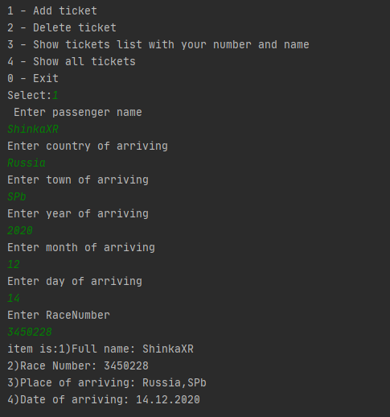

*Рисунок 1 – Протокол программы*

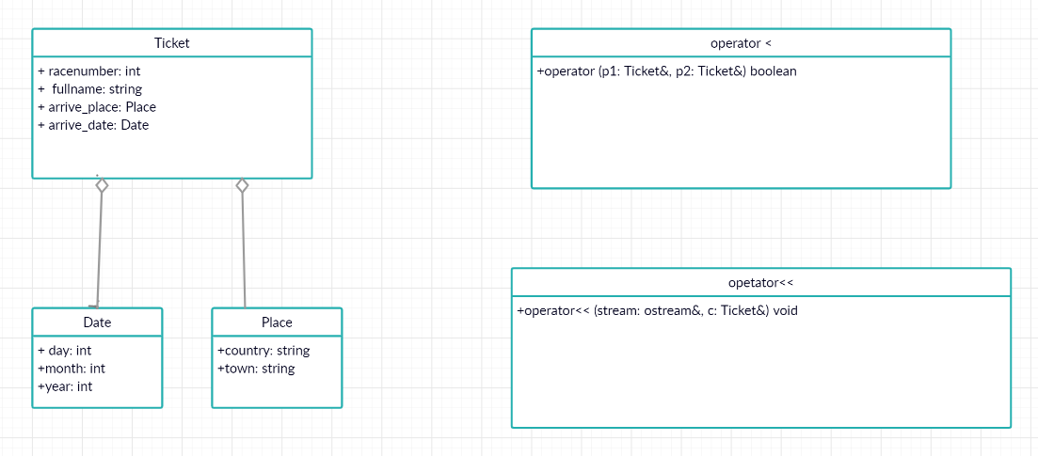

*Рисунок 2 – Диаграмма классов*